# Service Name - Apply for New Trade License

## Process Flow/Procedure

* Citizen can apply for the service on Web, Aaple Sarkar, and Mobile App or can visit CFC/ULB office. On Web, he can upload the supporting mandatory documents.
* Pay the prescribed fees either Online (Credit Card/Debit Card/Net Banking) or Offline (At ULB/CFC).
* Application no. is generated which further can be used by applicant to track the application.
* Applicant will be informed through SMS and email for every important event.
* Verification of documents will be done at ULB/CFC counter. Citizen needs to submit the copies of the documents at the ULB/CFC counter. ULB/CFC clerk will check all the documents and authorize or Un-authorize the application.
* If application is un-authorized then citizen can re-submit document or can correct the application form.
* If application is authorized then it will be scrutinized (if applicable) by the respective department.
* If application is rejected during final scrutiny then rejection letter will be generated and intimated to applicant through SMS and email.
* Once the application is scrutinized (if applicable), LOI charges will be auto populated based on charge master setup and generate the LOI (if applicable).
* Applicant needs to make the payment against the LOI (if applicable).
* Later, Citizen will avail the digitally signed certificate against the service applied through online login or from the ULB/CFC counter.
* Timeline to complete the Services:

|  |  |
| --- | --- |
| Services | No. of days |
| New Trade License | 15 |

* Scrutiny Levels

|  |  |
| --- | --- |
| Services | No. of Scrutiny Levels |
| New Trade License | 3 |

## Service wise workflow

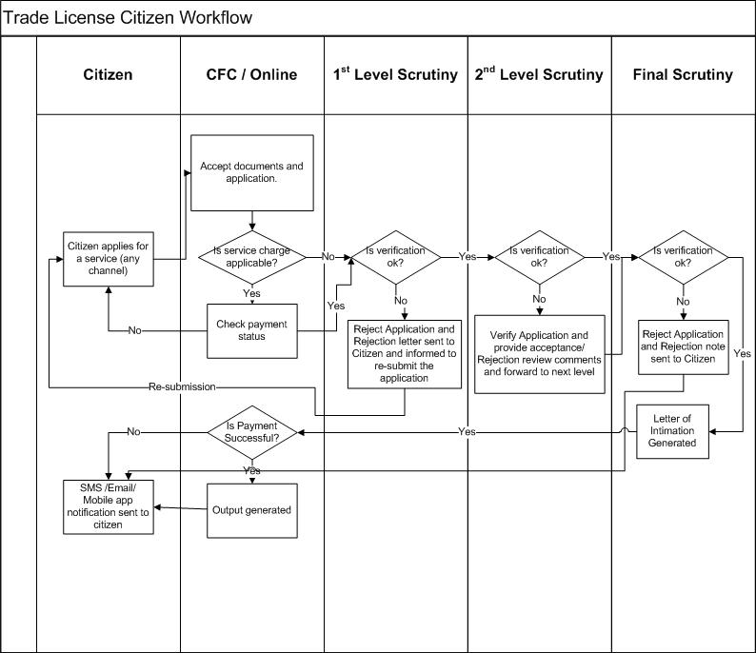

## Document checklist

|  |  |  |
| --- | --- | --- |
| Services | Required documents from Citizen | Documents verified by ULB |
| New Trade License | * Lease Deed/ Legal Occupancy | * Latest Property Tax Payment Details |
|  | * Partnership Deed (if partners involved) | * Latest Water Tax Payment Details |
|  |  | * Health NOC |
|  |  | * Occupancy Certificate |